Careers Handbook

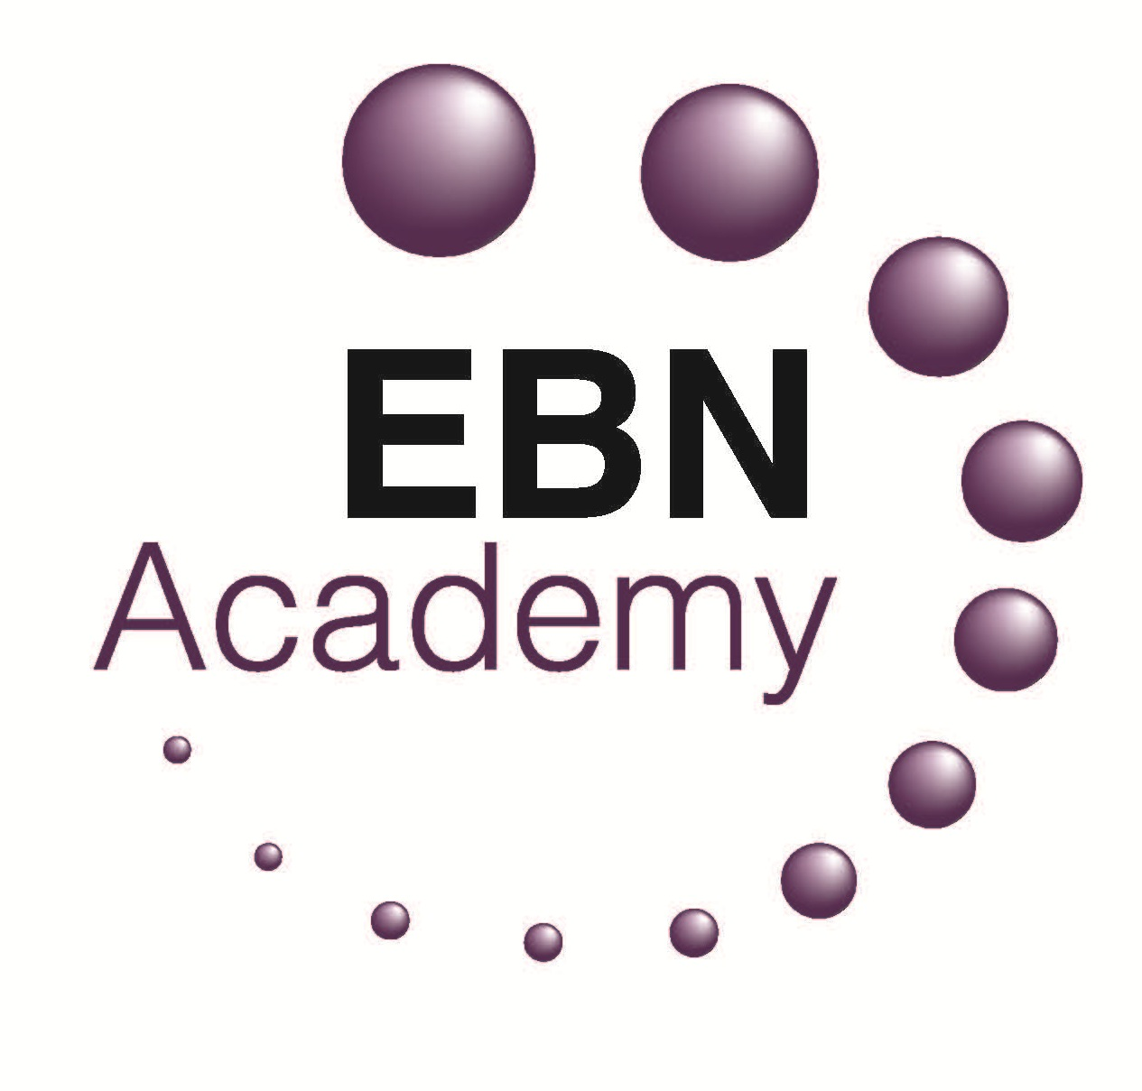

YOUR NEXT STEPS

Which path will you take?
A Levels? T Levels?
BTEC?
Apprenticeship?
Traineeship?

Do you aspire to go to university?
Do you want to combine study and working?

If you haven’t got an idea yet – don’t panic! We have a dedicated Careers Leader in Mr Sutherland to help you decide the right path for you.

A Levels are Advance of GCSE’s. They take two years of full-time study to complete. A Levels are academic qualifications that are usually studied in modules. A Levels will provide opportunities for developing and generating evidence for assessing the key skills; communication, information technology, improving own learning and performance, working with others, problem solving.

Example of A Level Subjects

Accounting | Drama & Theatre | Geology | Physics
Art & Design – Fine Art | Economics | German | Politics
Art & Design – Graphics & 3D Design | English Language | History | Psychology
Art & Design – Photography | English Literature | Law | Religious Studies
Biology | Film Studies | Mathematics | Sociology
Business | French | Media Studies | Spanish
Chemistry | Further Mathematics | Music | Statistics
Computer Science | Geography | Philosophy

The completion of A Levels will earn UCAS Tariff Points to apply for university.
Ucas Tariff points are a way of translating grades from a number of qualifications into a numerical value (the points required for entry on to a course).

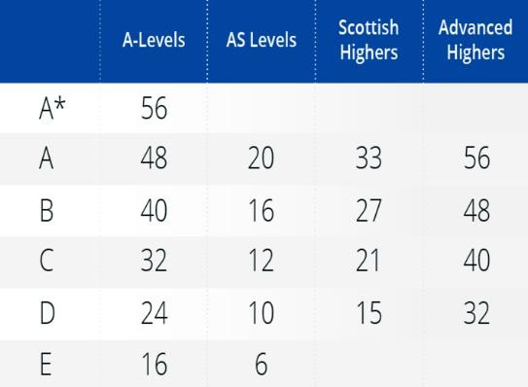

T Levels are equivalent to three A Levels. They take two years of full-time study to complete. It’s a great way to get into skilled employment, further study or higher apprenticeship.
T Level students spend 80% of their time in the classroom, learning about theory. The other 20% will be putting this into practice on 45 days (9 weeks) industry placement.

T Levels help to get real workplace experience, students will learn from specialist experts and helps develop the skills employers are looking for.
Example of T Level Subjects - **NEW 2023

Agriculture, Environment and Animal Care ** | Digital | Protective Services
Business and Administration | Engineering and Manufacturing | Sales, Marketing and Procurement
Catering and Hospitality ** | Hair and Beauty ** | Social Care
Construction | Health and Science | Transport and Logistics
Creative and Design ** | Legal, Finance and Accounting

The completion of T Levels will earn UCAS Tariff Points to apply for university.
Ucas Tariff points are a way of translating grades from a number of qualifications into a numerical value (the points required for entry on to a course).

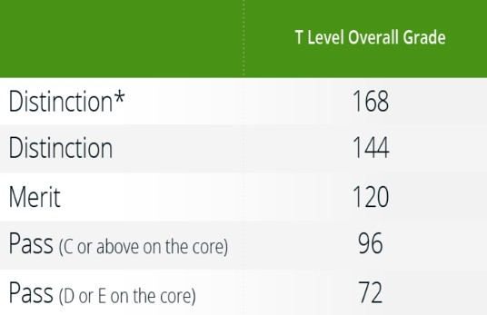

BTEC are a vocational form of study with a range of course choice. The courses tend to combine theory, practical and work related. You will learn by completing projects and assignments that are based on realistic workplace situations and activities. You will focus on a particular subject area and develop a range of specialist skills and knowledge. BTECs can be started at different levels.
Level 1 = Foundation, Level 2 = GCSE, Level 3 = A Level, Level 4-5 = Degree Level Nat. Ext Cert = 1 qualification, Nat. Dip = 2 qualifications, Nat. Ext Dip = 3 qualifications
Examples of BTEC courses

Accounting | Construction | Fashion | Music Performance & Production
Aerospace Engineering | Customer Service | Forensic & Criminal Investigation | Performing Arts
Animal Welfare & Veterinary Nursing | Digital Media Production | Foundation Learning | Photography
Art & Design | Early Years & Childhood Studies | Graphic Design | Plumbing
Backstage Production Arts | Electrical Installation | Hairdressing & Barbering | Psychology, Criminology & Law
Beauty Therapy & Make-Up | Electronic Engineering (Robotics) | Health & Social Care | Public Services
Built Environment & Sustainable  Technologies | Engineering | Hospitality & Catering | Science
Business & Management | ESOL | Manufacturing Engineering | Sport & Exercise Science
Computing & Emerging Technologies | Event Planning | Motor Vehicle | Travel & Cabin Crew

The completion of BTEC Level 3 will earn UCAS Tariff Points to apply for university.
Ucas Tariff points are a way of translating grades from a number of qualifications into a numerical value (the points required for entry on to a course).
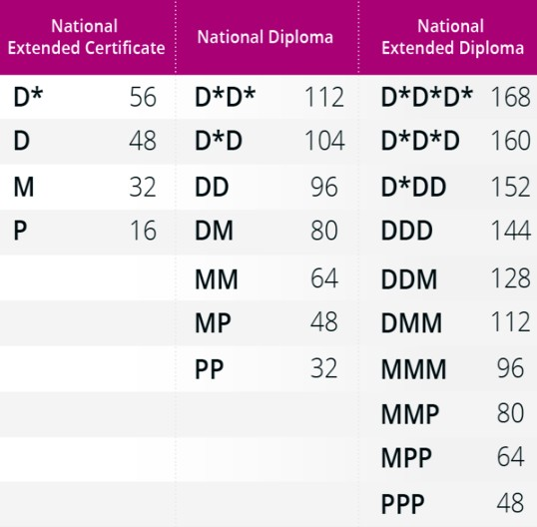

Apprenticeships are a brilliant way to break into an industry straight from school. You spend time working with an employer usually 4 days a week and 1 day studying towards a qualification (typically a BTEC) at a college or training provider.
A combination of earning money while you study.

Most apprenticeships are sponsored by the employer – they are investing in you! In most cases, a successful apprenticeship will result in full-time employment when completed.

Type of Apprenticeships
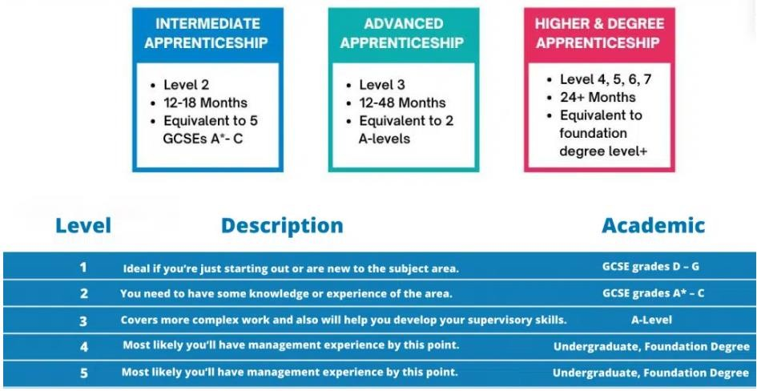

After completion of A Levels/T Levels/BTEC Level 3 or Advanced Apprenticeship you can apply for a higher/degree apprenticeship which is sponsored by your employer and will not encounter any university fees.

A traineeship is a course that supports 16–24-year-olds (25 if they hold an Education, Health and Care Plan) with gaining experience of the workplace to prepare them for an apprenticeship or work.

Traineeships are delivered by a range of providers, including, Colleges, Independent Training Providers, local authority providers and many more.

A traineeship aims to provide young people with the skills that employers are looking for and can last between 6 weeks – 1 year (but usually lasting 6 months) They are designed to bridge the gap between learning and employment.
What to expect:
- training to prepare you for work, including CV writing and what to expect in the workplace
- support to improve your English, maths and digital skills if you need it (mostly those students who acheive grade 2 or below in GCSE English and Maths)
- sector focused vocational learning to help prepare you for your apprenticeship or job and recognition of your learning

A traineeship is a training programme with work experience - it isn’t a job and you do not gain any formal qualifications. Employers are not required to pay you for the work placement, but they can support you with expenses such as transport and meals.

SUPPORT
PERSONAL GUIDANCE
Gatsby Benchmark 8
What the government says…. Every student should have opportunities for guidance interviews for guidance interviews with a career adviser, who could be an internal (a member of school staff) or external. These should be available whenever significant study or career choices are being made. Every student should have a least one such interview by the age of 16.

To help all our EBN students, we have a robust system in place to ensure provision of career interviews takes place for all students, whether face to face or virtually.

Interviews can help you explore various career options, provide you with specific industry information and give you advice about Post 16 destinations and the world of work.

The Careers Leader provide impartial Information, Advice and Guidance on a student rota basis.

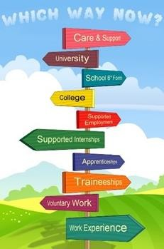
FINAL GCSE RESULTS WILL
DETERMINE YOUR ROUTES
FACT: Better the grades you achieve, better your choices.
What will you do?
PATHWAYS AFTER YEAR 11
Examples of where your final grades could take you;

Grammar 6th Form 7+ GCSES grade 6/7 or above with both English and maths at grade 6 A Levels 5+ GCSES grade 5 /6 or above with both English and maths
T Levels 5+ GCSES grade 5 or above including English and maths

BTEC Level 3 5+ GCSES grade 4 or above including both English and maths at grade 4 BTEC Level 2 4 GCSES grade 3 or above (resit English and/or maths if applicable)
BTEC Level 1 No formal qualifications (study/resit English and maths)
Apprenticeship (Adv) 5+ GCSES grade 4 or above including both English and maths at grade 4 Apprenticeship (Int) 4 GCSES with English and maths at grade 4
Traineeship No formal qualifications

SIXTH FORMS, COLLEGES OR APPRENTICESHIP PROVIDERS MAY ASK FOR SPECIFIC GRADES AT GCSE IN ORDER FOR YOU TO FURTHER STUDY. PLEASE ENSURE YOU READ ‘ENTRY REQUIREMENTS’ BEFORE APPLYING. STUDENTS WHO NEED ASSISTANCE IN APPLICATION MAKING, SEE THE CAREERS LEADER IN M5.
PROVIDERS WILL BASE CONDITIONAL OFFERS ON TARGET GRADES. A ‘CONDITIONAL OFFER’ IS ONLY SUBJECT TO
YOU GETTING THE GRADES REQUIRED. DON’T ASSUME WHEN YOU GET A CONDITIONAL OFFER YOU HAVE SECURED A PLACE!
***YOUR GCSE GRADES WILL STAY WITH YOU FOR THE REST OF YOUR WORKING LIFE. YOU WILL NEED TO DISCLOSE YOUR GCSE GRADES ON EVERY FUTURE COLLEGE, UNIVERSITY AND JOB APPLICATIONS.
MAKE THEM THE BEST THEY CAN BE!***

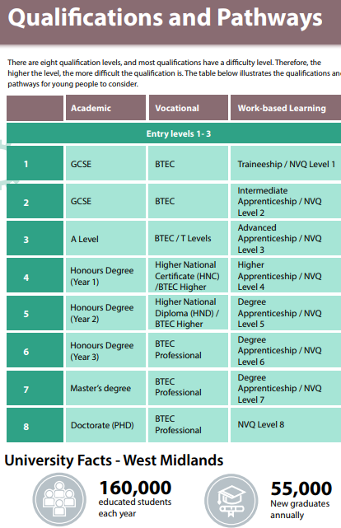
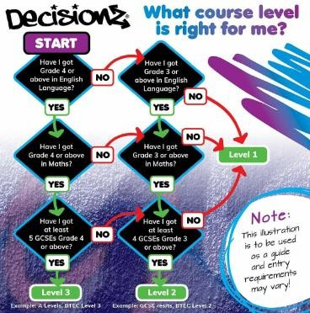
UNDERSTANDING DIFFERENT LEVELS

The majority of CHS students study GCSE which is Level 2.

Before you start applying for courses, you need to refer to your target grades.

Look and apply for courses appropriately.

It is important to check entry requirements for every course as sometimes it can vary from college to college

LIST OF PROVIDERS IN WEST MIDLANDS

College | Location | Address | Website | Telephone
Access Creative College | Digbeth Campus | 68 Heath Mill Lane, Birmingham B9 4AR | www.accesscreative.ac  .uk | 0800 28 18 42
Aston University Engineering Academy | Aston Triangle | 1 Lister Street, Birmingham B7 4AG | www.auea.co.uk | 0121 380 0570
BIMM Birmingham (Music College) | Digbeth | 93-96 Floodgate St, Deritend, Birmingham B5 5SR | www.bimm.ac.uk | 0344 2 646  666
Birmingham Metropolitan College (BMET) | Sutton Coldfield | 34 Lichfield Road, Sutton Coldfield B74 2NW | www.bmet.ac.uk | 0121 446 4545
Birmingham Metropolitan College (BMET) | James Watt Campus | Aldridge Road, Great Barr B44 8NE | www.bmet.ac.uk | 0121 446 4545
Birmingham Metropolitan  College (BMET) | Matthew Boulton | Jennens Road, Birmingham B4 7PS | www.bmet.ac.uk | 0121 446 4545
Birmingham Metropolitan College (BMET) | Art & Design Centre | Venture Way, Brierley Hill DY10 1AA | www.bmet.ac.uk | 0121 446 4545
Birmingham Metropolitan College (BMET) | Erdington Skills Centre | Edwards Road, Erdington B24 9EW | www.bmet.ac.uk | 0121 446 4545
Birmingham Metropolitan College (BMET) | Kidderminster Academy | Piano Building, Weavers Wharf, Kidderminster DY11 7DY | www.bmet.ac.uk | 0121 446 4545
Birmingham Metropolitan College (BMET) | Stourbridge College | Hagley Road, Stourbridge DY8 1QU | www.bmet.ac.uk | 0121 446 4545
Birmingham Metropolitan College (BMET) | The Botanical Gardens | Westbourne Road B15 3TR | www.bmet.ac.uk | 0121 446 4545
Birmingham Metropolitan College (BMET) | Centre Of Sporting Excellence | Brintons Field, Zortech Avenue, Kidderminster DY11 7DY | www.bmet.ac.uk | 0121 446 4545
Birmingham Ormiston Academy (BOA) | City Centre | 1 Grosvenor Street, Birmingham B4 7QD | www.boa- academy.co.uk | 0121 359 9300
Bournville College South & City | Longbridge | 1 Longbridge Lane, Longbridge B31 2TW | www.sccb.ac.uk | 0800 111 6311
Cadbury Sixth Form College | Kings Norton | Downland Close, Birmingham B38 8QT | www.cadcol.ac.uk | 0121 458 3898
Joseph Chamberlain Sixth Form College | Highgate | 1 Belgrave Road, Birmingham B12 9FF | www.jcc.ac.uk | 0121 446 2200
National College for High Speed Rail | Aston Triangle | 2 Lister St, Birmingham B7 4AG | www.nchsr.ac.uk | 0330 120 0375
Solihull College | Blossomfield Campus | Blossomfield Road, Solihull B91 1SB | www.solihull.ac.uk | 0121 678 7000
Solihull College | Woodlands  Campus | Auckland Drive, Solihull B36 0NR | www.solihull.ac.uk | 0121 678 7000
Solihull Sixth Form College | Solihull | Widney Manor Road, Solihull B91 3WR | www.solihullsfc.ac.uk | 0121 704 2581
South And City College | Bordesley Green Campus | Fordrough Lane, Birmingham B9 5NA | www.sccb.ac.uk | 0800 111 6311
South And City College | Digbeth Campus | High St, Deritend, Birmingham B5 5SU | www.sccb.ac.uk | 0800 111 6311
South And City College | Hall Green Campus | Cole Bank Road, Hall Green, Birmingham  B28 8ES | www.sccb.ac.uk | 0800 111 6311
South And City College | Handsworth Campus | Soho Road, Birmingham B21 9LR | www.sccb.ac.uk | 0800 111 6311
University College Birmingham (UCB) | City Centre | Summer Row, Birmingham B3 1JB | www.ucb.ac.uk | 0121 604 1000
WMG Academy For Young Engineers | Chelmsley Wood | Chelmsley Road, Solihull B37 5FD | www.solihull.wmgacad emy.org.uk | 0121 289 3556

Grammar 6th Forms | Location | Address | Website | Telephone
Bishop Vesey's Grammar School (mixed 6th Form) | Sutton Coldfield | Lichfield Road, Sutton Coldfield, Birmingham B74 2NH | www.bvgs.co.uk | 0121 250 5400
King Edward VI Handsworth Boys  Grammar School | Birmingham | Grove Road, Birmingham B21 9ET | www.handsworth.bha m.sch.uk | 0121 554 2794
King Edward VI Aston School | Aston | Frederick Road, Aston, Birmingham B6 6DJ | www.keaston.bham.sc h.uk | 0121 327 1130
King Edward VI Camp Hill School for Boys | Kings Heath | Vicarage Road, Kings Heath, Birmingham B14 7QJ | www.camphillboys.bha m.sch.uk | 0121 444 3188
King Edward VI Camp Hill School for Girls | Kings Heath | Vicarage Road, Kings Heath, Birmingham B14 7QJ | www.kechg.org.uk | 0121 444 2150
King Edward VI Handsworth School for Girls | Handsworth | Rose Hill Road, Handsworth, Birmingham B21 9AR | www.kingedwardvi.bh am.sch.uk | 0121 554 2342
King Edward VI Five Ways School (mixed) | Bartley Green | Scotland Lane, Bartley Green, Birmingham B32 4BT | www.kefw.org | 0121 472 1147
Sutton Coldfield Grammar School for Girls | Sutton Coldfield | Jockey Road, Sutton Coldfield, Birmingham B73 5PT | www.suttcold.bham.sc h.uk | 0121 345 1479
Local 6th Forms | Location | Address | Website | Telephone
Archbishop Ilsley | Birmingham | Victoria Road, Birmingham B27 7XY | www.ilsley.bham.sch.u k | 0121 706 4200
Ark St Albans | Birmingham | Conybere Street, Birmingham B12 0YH | www.arkstalbans.org | 0121 446 1300
Bordesley Green Girls | Birmingham | Bordesley Green Road, Birmingham B9 4TR | www.bordbrng.bham.s ch.uk | 0121 464 1881
Heartlands Academy | Birmingham | Great Francis Street, Nechells, Birmingham B7 4QR | www.heartlandsacade my.e-act.org.uk | 0121 464 3931
John Henry Newman | Birmingham | Chelmsley Road, Chelmsley Wood, Birmingham B37 5GA | www.johnhenrynewmanc atholiccollege.org.uk | 0121 770 5331
King Edward VI Sheldon Heath Academy | Birmingham | Sheldon Heath Road, Birmingham B26 2RZ | www.keshacademy.co m | 0121 464 4428
Small Heath Lower School | Birmingham | Waverley Road, Birmingham B10 0EW | www.smallheathacade my.com | 0121 464 7997
Waverley Studio College | Birmingham | Yardley Green Road, Birmingham B9 5QA | www.waverleystudioco llege.co.uk | 0121 566 6622
Training Providers | Location | Address | Website | Telephone
Bellis Training Limited | Birmingham | Hastingwood Ind, Pk Wood Lane, Birmingham B24 9QR | www.nvq-centre.co.uk | 0121 270 1067
Crackerjack Training Ltd | Birmingham | 78-79 Francis Road, Birmingham B16 8SP | www.crackerjacktraini ng.co.uk | 0121 454 2043
Creative Alliance | Birmingham | 213 Scott House, Custard Factory, Gibb Street, Birmingham, B9 4AA | www.creativealliance.o rg.uk | 0121 753 0049
Make UK | Birmingham | Hubs Across Birmingham | www.makeuk.org | 0808 168 5874
GB Training | Birmingham | Wynner House, 143 Bromsgrove Street, Birmingham B5 6RG | www.gbtraining.org.uk | 0121 622 4218

Gordon Franks Training | Birmingham | St James House, 1 St James Place, Birmingham B7 4JE | www.gordonfrankstrai ning.co.uk | 0121 333 3001
Heart Of England Training Ltd | Birmingham | 12 The Priory, Queensway, Birmingham B4 7LJ | www.hoet.co.uk | 0121 236 8595
JTL | Birmingham | Mill Street, Birmingham B6 4BS | www.jtltraining.com | 0800 085 2308
Key Training | Birmingham | 148 Great Charles Street, Queensway, Birmingham B3 3HT | www.keytraining.co.uk | 0121 236 7512
Learn Direct Limited | Birmingham | 4th Floor Grosvenor House, Bennets Hill, Birmingham B2 5RS | www.learndirect.com | 024 7670 7921
Midland Group Training Services | Coventry | Midland Group Training Services, Gulson Road, Coventry CV1 2JG | www.mgts.co.uk | 024 7663 0333
Motivational Preparation College For Training  (MPCT) | Birmingham | Balaam Wood Academy, New Street, Frankley, Birmingham | www.mpct.co.uk | 0330 111 3939
New Horizons | Birmingham | Unit 30, Bordesley Trading Estate, 19 Bordesley Green Road, Birmingham B8 1BZ | www.newhorizons.co m | 0121 328 7995
New Horizons | Birmingham | 111 Bishopsgate Street, Birmingham B15 1ET | www.newhorizons.co m | 07949 592475
Nova Training | Birmingham | 161-163 Station Road, Birmingham B33 8BA | www.novatraining.co.u k | 0121 783 9824
Pathway First | Birmingham | 95 Amington Road, Birmingham B25 8EP | www.pathwaygroup.co  .uk | 0121 707 0550
PeoplePlus | Birmingham | 6th Floor, Edmund House, 12-22 Newhall Street, Birmingham B3 3AS | www.peopleplus.co.uk | 0800 345666
Protocol Consultancy | Birmingham | 1 New Market Street, Birmingham B3 2NH | www.protocolgroup.or g.uk | 0121 236 2634
Performance Through People | Birmingham | Mill House, 7 Mill Street, Birmingham B6 4BS | www.ptp- training.co.uk | 0121 643 2653
Reflections Training Academy | Birmingham | 2 Commercial Street, Birmingham B1 1RS | www.reflectionstrainin g.co.uk | 0121 643 2147
South And City, Digbeth Campus | Birmingham | High St, Deritend, Birmingham B5 5SU | www.sccb.ac.uk | 0800 111 6311
Solihull College & University Centre | Blossomfield Campus | Blossomfield Road, Solihull B91 1SB | www.solihull.ac.uk | 0121 678 7000
The Development Manager Ltd | Birmingham | 220 Scott House, The Custard Factory, Gibb Street, Birmingham B9 4AA | www.thedevelopment manager.com | 0333 101 0040
Apprenticeships | Website
To Search For Apprenticeships | www.gov.uk/apply-apprenticeship
Information on Apprenticeships | www.getinsofar.gov.uk
Information on Apprenticeships | www.gov.uk/topic/further-education-skills/apprenticeships

INTERESTED IN SPORT
There are numerous of opportunities if you play a sport or interested in playing a sport. Please ask Mr Sutherland for more information.

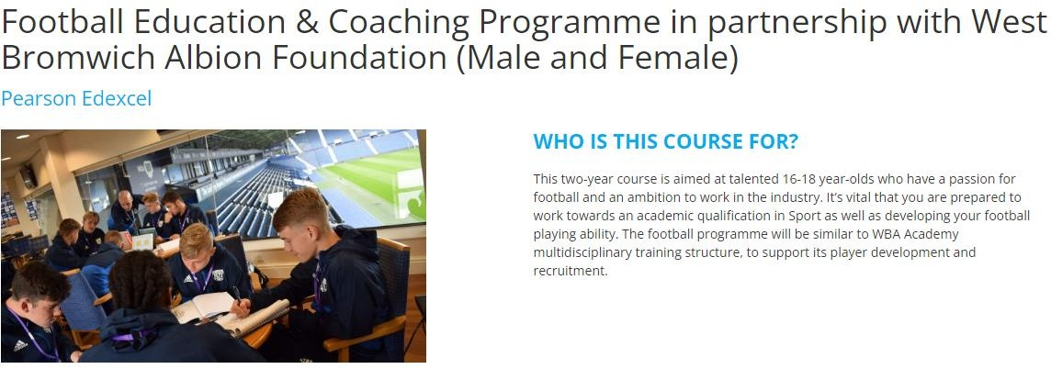

16-19 BURSARY FUND

You could get a bursary to help with education-related costs if you’re aged 16 to 19

For more information: www.gov.uk

A bursary is money that you, or your education or training provider, can use to pay for things like:

- clothing, books and other equipment for your course
- transport and lunch on days you study or train

You could get a bursary worth up to £1,200, depending on your circumstances and benefits.
You could get a discretionary bursary if you need financial help but do not qualify for a bursary for students in vulnerable groups. Your education or training provider decides how much you get and what it’s used for.

College will have their own criteria for discretionary bursaries. They’ll look at your individual circumstances - this usually includes your family income.

Your provider will decide how you get your bursary. You might be:

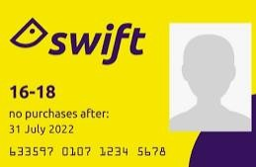
- paid in full or instalments, in cash or through a bank account

- given things like a travel pass, free meals or books instead of money

Some providers also offer one-off payments to cover study trips or travel for university interviews.

Please be encouraged to ask to see if you qualify.

LABOUR MARKET INFORMATION

GATSBY BENCHMARK 2 – Learning from the Labour Market Information
IT’S GOOD TO KNOW WHAT JOB SECTORS ARE GROWING IN THE WEST
MIDLANDS, SEE BELOW WHICH JOB SECTORS ARE CURRENTLY ON THE RISE.
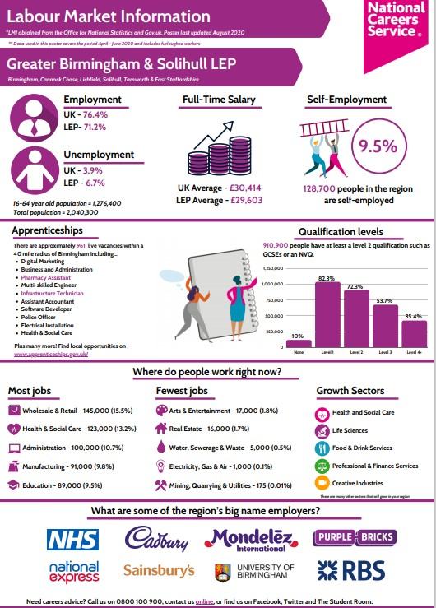

USEFUL LINKS TO HELP YOU EXPLORE

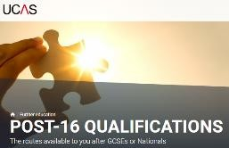
www.ucas.com

https://www.gov.uk/apply-apprenticeship

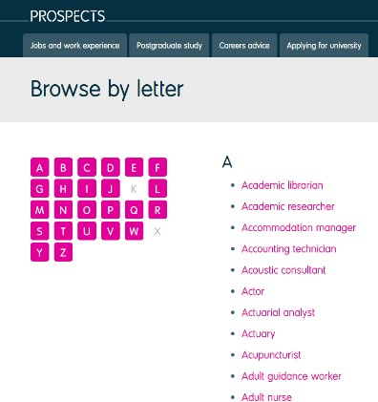
www.nationalcareersservice.direct.gov.uk

www.u-explore.com www.prospects.ac.uk

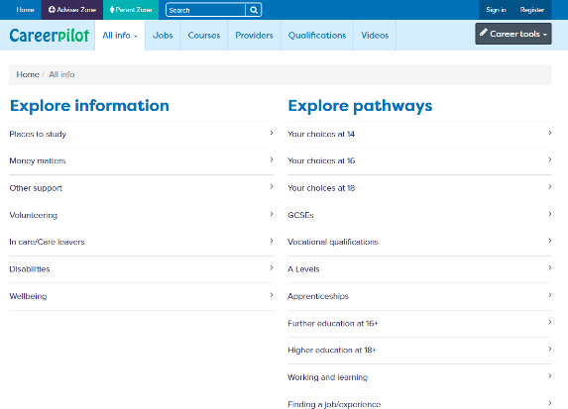
www.university.which.co.uk www.careerpilot.org.uk
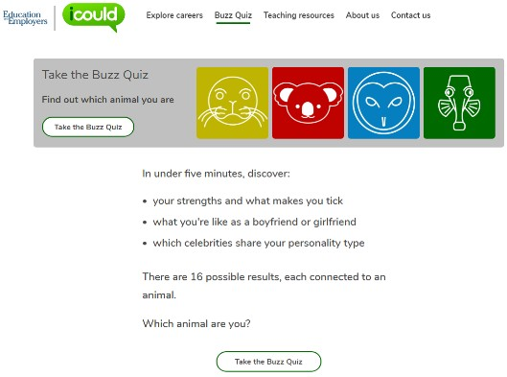
www.icould.com www.lmiforall.org.uk

APPLICATIONS

What should you be doing during Autumn Term?
Guidance - Still unsure what you want to do - talk to the Careers Leader Mr Sutherland.
Research - start looking at Local Providers and courses. Book onto Open Days. Do you want to do A Levels, T Level or BTEC? Some colleges allow you to do a mix of both.
Apply - get your applications in early as courses start filling up quickly. There are 79 secondary schools in Birmingham (over 12,000 students) competing for Further Education places. Applications tend to be completed online. There is no limit in the amount of applications you make. If you are made an offer accept it - do not decline any offers.

Course 1. Be Realistic - look at entry requirements close to your target grades Course 2. Be Aspirational - look at courses in case you do better than predicted
Course 3. Edge your bets - just in case something doesn’t go to plan look at alternative courses. (E.g. BTEC instead of A Levels)

FE courses will open from October.

Apprenticeships – Companies will advertise for positions throughout the year, its important to keep checking periodically.
Lots of apprenticeships can be found on the GOV.UK website - Find an apprenticeship: https://www.gov.uk/apply-apprenticeship
If you have a specific company you would like to work for (i.e JLR, BMW, BT) keep checking their website for updates they tend to be from January onwards.
If you want to apply for an apprenticeship, please ensure you sign up for notifications on the National Apprenticeship Website www.apprenticeships.gov.uk

REFERENCES AND INTERVIEWS

All students need to make at least 1 application by December. Do not wait for mocks and mocks results. Colleges make offers based on teacher predictions/references. College places are competitive so early applications are advisable.

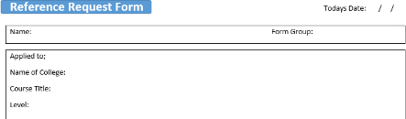
Once applications are made, please request a reference to support your application.

References will be emailed directly to the college/FE Provider. Paper versions can be requested.

**If your college asks for a name or email details for your referee please use;

Next steps;

You should now prepare for your Interview?
Interviews - Colleges/FE Providers will invite students for interview. Interviews may be conducted by telephone, virtually or in person. If any student needs assistance/practice for their interview, please do not hesitate to ask the Careers Leader.

If you are required for interview during the school day, you will need to provide evidence and seek permission from the Attendance Team.

POST 16 OFFERS

When you have made an application and attended your interview, you may be made an offer.

Conditional Offer – you must achieve the grades to gain a place. This is not a guarantee you have been accepted.

Unconditional – in exceptional circumstances, colleges will make these to students who have impressed and want them to join their college regardless of GCSE grades.

Unsuccessful – this could be a number of things. i.e., you have applied to a course and your target grades to not match the entry requirements or there are errors on your application or misconduct – seek help from the Careers Leader who can advise you.

What should you do if you do not hear from colleges or providers?
Be patient and ask for help! - Keep applying if you haven’t had any offers. Let your
Achievement Leader and Careers Leader know.

You have applied to multiple colleges?
Consolidate – Start thinking about your offers and preferences. However, do not reject any offers made to you.

You do not need to decide about where you are going until you have opened your GCSE Results in August.

GLOSSARY
GCSEs – are British educational qualifications which schoolchildren take when they are fifteen or sixteen years old. GCSE is an abbreviation for 'General Certificate of Secondary Education'.
BTECs – BTECs are vocational, work-related qualifications that aim to engage and inspire learners in a wide range of subjects. The content of your course and the knowledge you will gain depends on the subject you choose. The aim of a BTEC is to develop skills that apply to the workplace and will be beneficial for the future, and so your learning will be tailored around the specific sector you are studying. BTECs develop more practical knowledge and provide a different approach to learning, based alongside a theoretical background.
Sixth Form – a sixth form is an educational institution in where students aged 16 to 19 typically study for advanced school-level qualifications, such as A-levels, BTEC Level 3 and the International Baccalaureate Diploma, or school- level qualifications such as GCSEs. Sixth forms, usually, prepare you for university/degree apprenticeships.
A-levels – Advanced levels are the most common step-up from GCSEs. They normally take two years to complete, full-time and are at Level 3. They would usually need at least five GCSEs at grades 9 to 4 to be able to study them. Some providers require you to have grade 4 or above in English and Maths, or grade 5 or above in the subject you want to take. You usually choose the A-levels that you wish to study in Year 11, but you do have the chance to change your choices after receiving your GCSE results or after a week or so of the course if it is not what you expected. There is a wide range of around 80 subjects available, although exact courses on offer will change depending on the college or sixth form you choose.
Further Education (FE) Colleges – FE colleges generally offer vocational (work-related) and specialist qualifications. Examples might include qualifications in construction, hair and beauty, animal care etc. They tend to provide courses for 16-18 year olds as well as adult learners, and often have close links with the community. FE colleges offer a wide range of courses at a variety of levels. FE colleges, on the whole, prepare you for the world of work.
T Levels - these 2-year courses have been developed in collaboration with employers and businesses to prepare students for work. T Levels will offer students a mixture of classroom learning and ‘on-the-job’ experience during an industry placement of at least 315 hours (approximately 45 days). They will provide the knowledge and experience needed to open the door into skilled employment, further study or a higher apprenticeship.
Apprenticeships – to get your career started you usually need a combination of experience and qualifications. An apprenticeship gives you both by combining on the job training with study (usually one day a week) meaning you can earn while you learn. With some apprenticeships you can even get a degree. It usually takes between one and four years to complete an apprenticeship depending on which level you take. Apprenticeships are available across a wide range of industries and many high-quality, prestigious companies offer them.
Traineeships – a traineeship is an education and training programme with work experience that unlocks the great potential of young people and prepares them for their future careers by helping them to become ‘work ready’. Designed to help young people aged 16 to 24 who don’t yet have the appropriate skills or experience, traineeships provide the essential work preparation training, English, maths and work experience needed to secure an apprenticeship or employment.
University – a higher-level educational institution in which students study for degrees and academic research is done. University is, usually, attended after students have completed suitable Level 3 qualifications such as A Levels and BTECs etc. Higher (degree) apprenticeships may fund a young person’s part-time university degree at the same time as getting paid for working in a job.
Russell Group Universities – (sometimes called Red Brick) the Russell Group represents 24 leading UK universities which are committed to maintaining the very best research, an outstanding teaching and learning experience and unrivalled links with business and the public sector.

