COVID - 19 EBN Academy Re-opening:
Parent Guidance – Updated 15th June 2020
DFE guidance currently states that we are able to open for Year 10 students, Year 11 students who need any careers advice and guidance, children classed as vulnerable (those in care or with social care involvement) or those who have parents classed as key worker.
We are very aware that students and parents/carers will have concern about their child returning to school. To support this, in line with government guidance we have put together the following guidance and information for parents so that they can make an informed choice about sending their child to school. We are very much looking forward to welcoming small groups of students back into the Academies and would encourage you, where you feel comfortable, to send you children in. While we appreciate that school will look different to when it closed, it will be beneficial to students have subject specific input from teachers.
Who is are the Government advising are now allowed to come to school?
Children classed as Vulnerable and those with Key workers as parents:
We continue to be ready to provide education for students in Year 9, 10 and 11 who are classed as vulnerable or who have key workers as parents if it is required. At present we have had no confirmed requests for this provision however if your child falls into one of these categories and you require onsite education please let us know as soon as possible. We will need advance warning if you require this provision to allow us to adequately plan sessions and provide appropriate staffing levels.
Year 10
From 15th June EBN Academies are open to small groups of Year 10 students. Due to Government guidance stating that only 25% of Year 10 pupils can attend on a given day students will only be able to attend on 1 day per week in the first instance. As things progress this may change based on confirmed student numbers and further guidance. We will keep in touch with Year 10 students/parents on a weekly basis to update them on developments and ask for confirmation about student’s attendance onsite for the next week. If parents have not confirmed with us that their child will be attending then they will not be permitted onsite if they arrive at school. It is essential that parents communicate your intentions so that we can meet health and safety requirements and provide the appropriate number of teaching staff.
Alongside onsite provision we will continue to provide weekly work packs and complete safe and well-being phone calls/home visit for those students who don’t attend onsite. We will also be providing interactive learning resources to support home-learning at this time.
Year 11
From 15th June 2020, Year 11 students will continue to be provided with careers advice/guidance and support around their post-16 plans and applications. There may be opportunity for this to take place face-to-face and where this is possible it will be in the form of an appointment with an identified member of staff. If this is possible and your child needs this support, we encourage you to send your child in to school to have these discussions. If your child needs support but you are not comfortable to send them to school, we will provide advice and guidance over the phone.
In terms of ongoing contact with Year 11, we are no longer providing work packs for Year 11 students as they would have now finished their curriculum work, however we will continue to complete safe and well phone calls to check on student/family welfare. This will continue until the end of June.

This year’s GCSE results will be published on 20th August 2020. We are not yet clear on how the results day will be organised as this will depend very much on the national and local guidance at the time, however we will be in contact in good time to give you the details of how students can collect their results. Throughout the process we will be on hand to support your child with any issue relating to Post -16 applications. This support will continue into September and beyond so that we can help you ensure your child settles well into the next phase of their education, employment or training. If there is anything that we can do to support this transition please do not hesitate to contact us.
Year 9
We will continue to provide work packs for Year 9 and complete safe and well-being phone calls/home visits for those students who don’t attend onsite. In addition to this we are providing interactive lessons that Year 9 students will be able to access from home to supplement work packs. We are also currently looking at the latest DFE guidance and may be in a position to offer Year 9 some face to face provision before the summer holidays. This is most likely to take the form of short periods of time on site, in small groups, working with key teaching staff. In the first instance year 9 students would only be offered 1 day a week provision. This may increase depending on numbers of confirmed students.
Health and Safety of Staff and Students
The following sections details general information about how we are keeping staff and students safe at the current time:
- All people entering the site will have their temperature taken using an infra-red thermometer. Those displaying an abnormal temperature will be refused entry to the site.
- Classrooms and other learning environments such as workshops and science labs are organised to maintain space between seats and desks where possible in line with national guidelines
- Decisions on which lessons or activities will be delivered will be taken based on the normal curriculum delivered
- Decisions around the timetable and selection of classrooms or other learning environments used will take into account the need to reduce movement around the school or building
- Start and finish times are staggered to help avoid congestion of people
- All unnecessary items have been removed from classrooms and other learning environments where there is space to store it elsewhere to make room to support social distancing
- The Academy will ensure that young people are in the same small groups at all times each day, and different groups are not mixed during the day, or on subsequent days
- The Academy aim to ensure that wherever possible young people use the same classroom or area of a setting throughout the day, with a thorough cleaning of the rooms at the end of the day. Students will be seated at the same desk each day if they attend on consecutive days
- The Academy will ensure that sufficient handwashing facilities are available. Where a sink is not nearby, provide hand sanitiser in classrooms and other learning environments
- The Academy will ensure that clean surfaces that children and young people are touching, such as books, desks, chairs, doors, sinks, toilets, light switches, bannisters, more regularly than normal
- The Academy will ensure there is opportunity for all member of the community to frequently wash their hands with soap and water for 20 seconds and dry thoroughly. Review the guidance on hand cleaning (
- The Academy will ensure all students and staff wash their hands on arrival at the setting, before and after eating, and after sneezing or coughing.
- The Academy will prop doors open, where safe to do so (bearing in mind fire safety and safeguarding), to limit use of door handles and aid ventilation
- Lunch breaks will currently not be required but if need, they will be staggered - young people should clean their hands beforehand and have lunch in the groups they are already in. Groups will be kept apart as much as possible and tables will be cleaned between each group. If such measures are not possible, students will be brought their lunch in their classrooms.

Student Expectations:
Students planning to attend will be confirmed with parents at some point in the week before expected attendance. It is important that confirmed students ensure they attend at the time and on the day agreed so that an accurate record can kept. This information will be used to prepare for Fire evacuation purposes.

Student are expected to follow the normal rules of EBN Academy but a strong emphasis will be placed on adhering to the social distancing guidelines. The Academy Behaviour Policy has been amended with an appendix added specifically relating to COVID-19.This can be found on the school website. Any pupil not adhering to school rules or social distancing rules will be referred to the Deputy Head Teacher or Head Teacher for further action. Specific issues relating to students include:

- Students will be given a time to arrive onsite based on their teaching group and confirmed numbers
- Arrival times will be staggered to support social distancing, avoid unnecessary congestion and discourage social gatherings in the local areas and on public transport
- Students are expected to attend in school uniform
- Only students confirmed as attending of the day will be permitted access to the site
- Students will be met by Head Teacher and Deputy Head Teacher
- On arrival students will be registered using a paper register held in reception.
- On arrival students will have access to their pack to deposit their mobile phone and other belongings
- On arrival students will be have temperature taken by infra-red thermometer
- Student will be escorted up to their classroom by a Head Teacher of Deputy Head Teacher.
- Students and staff will be expected to maintain a 2 metre distance (marking on the floors will identify this distance).
- Students will arrive at the classroom and where the class teacher will take over.
- Students will be informed that they will remain in the classroom and the teacher will move to them
- Dismissal times will be staggered to support social distancing, avoid unnecessary congestion and discourage social gatherings in the local areas and on public transport
- Student belongings/packs will be returned to the students on their departure from the building.
- Head Teacher/Deputy Head Teacher will open the front doors to prepare for students leaving the building
- Once all students have their belongings and are ready to depart the teacher will escort them downstairs to reception.
- Students will exit the building immediately and be collected or make way go straight to the bus stop.

STUDENTS ARE EXPECTED TO ENSURE THEY KEEP 2 METRES DISTANCE FROM ALL OTHER MEMBERS OF THE SCHOOL COMMUNITY.
STUDENTS ARE EXPECTED TO FOLLOW ALL EXPECTATIONS IN RELTION TO THEIR CONDUCT IN SCHOOL. THE EBN BEHAVIOUR POLICY OUTLINE THESE EXPECTATIONS

Classrooms:
Government guidelines recommend ‘half’ of the class as appropriate. This would be 5 maximum for any one class at EBN 1 or 2. Classrooms have been marked out to support social distancing
Equipment:
- All equipment that is to be used will be cleaned using antibacterial wipes prior to being issued. The equipment will be centralised in each room in a tray for collection and return. Antibacterial wipes used to clean all equipment before collection and on return.
- Students will continue to use the same equipment for the duration of their time on site.
- All classrooms will have Antibacterial wipes, hand sanitiser gel and tissues
- Doors will remain open to aid ventilation
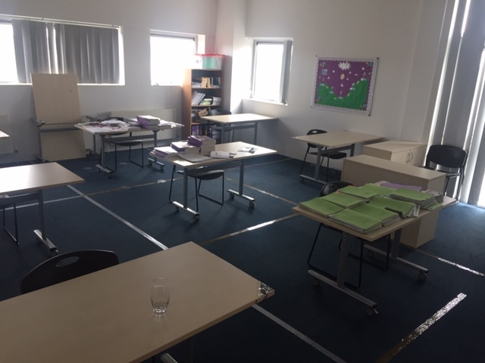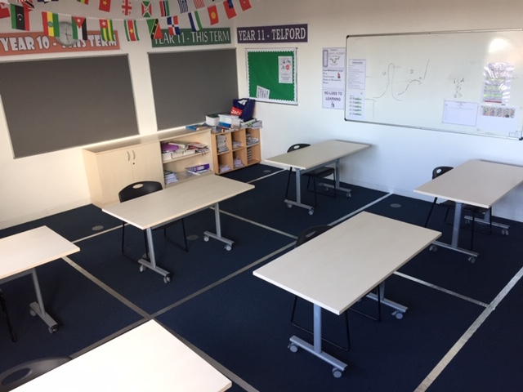
Toilets
As is normal there will be separately allocated toilets for staff and students and if a toilet is used it will be cleaned before the next person uses it.
General Guidance/Expectations
There are important actions that parents/carers can take during the COVID-19 outbreak, to help prevent the spread of the virus.
These include:
- Not sending your child to school if they or any member of their household has coronavirus symptoms. If a child develops symptoms while at school they will be isolated and sent home as soon as possible. In the event that your child or a member of your household display symptoms you are expected to follow government guidance around self-isolation
- minimising your child and family’s contact with individuals who are unwell by ensuring that those who have coronavirus symptoms, or who have someone in their household who does, do not attend childcare settings, schools or colleges
- cleaning hands more often than usual - wash hands thoroughly for 20 seconds with running water and soap and dry them thoroughly or use alcohol hand rub or sanitiser ensuring that all parts of the hands are covered
- ensuring good respiratory hygiene by promoting the ‘catch it, bin it, kill it’ approach
- Avoid touching your mouth, nose and eyes
- cleaning frequently touched surfaces often using standard products, such as detergents and bleach
- Stagger the use of staff rooms and offices to limit occupancy and maintain social distancing at all times.
- Avoid making close contact with people
- Adjust transport arrangements where necessary

Guidance on PPE
Wearing a face covering or face mask in schools or other education settings is not recommended. Face coverings may be beneficial for short periods indoors where there is a risk of close social contact with people you do not usually meet and where social distancing and other measures cannot be maintained. This does not apply to schools or other education settings. EBN Academy therefore do not require staff or students to wear face coverings.
Staff will only need to wear PPE in school in a very small number of cases including:
- Dealing with a young person whose care routinely already involves the use of PPE due to first aid requirements or intimate care needs.
- If a young person or staff member becomes unwell with symptoms of coronavirus while in the Academy and needs direct personal care until they can return home. A fluid-resistant surgical face mask should be worn by the supervising adult if a distance of 2 metres cannot be maintained. If contact with the young person or staff member is necessary, then disposable gloves, a disposable apron and a fluid-resistant surgical face mask should be worn by the supervising adult. If a risk assessment determines that there is a risk of splashing to the eyes, for example from coughing, spitting, or vomiting, then eye protection should also be worn

Guidance to parents and pupils for travelling to and from school
Where possible avoid the use of public transport, walk, cycle or travel by car if possible. The Academy has amended start times for pupils to allow them extra time to arrive if needed. We will also provide secure storage for bikes used by pupils. The later start times also mean that if pupils have to use public transport, they will not be travelling during peak times
If you have to use public transport
In line with government guidance if you are required to use public transport you must use a face covering. There are some circumstances when wearing a face covering may be marginally beneficial as a precautionary measure. The evidence suggests that wearing a face covering does not protect you, but it may protect others if you are infected but have not yet developed symptoms. This is most relevant for short periods indoors in crowded areas. You should be prepared to remove your face covering if asked to do so by police officers and police staff for the purposes of identification.
Keep your distance from people outside your household. Public Health England recommends keeping a distance of 2 metres, where possible. The key thing is to not be too close to other people for more than a short amount of time, as much as you can.
There may be situations where you can’t keep a suitable distance from people, for example when boarding, on busier services or at busier times of day. In these cases, you should avoid physical contact, try to face away from other people, and keep the time you spend near others as short as possible. If you can, wear a face covering on public transport. You should be prepared to remove your face covering if asked to do so by police officers and police staff for the purposes of identification.
Be aware of the surfaces you touch. Be careful not to touch your face. Cover your mouth and nose with a tissue or your elbow when coughing or sneezing.
Treat transport staff with respect and follow instructions from your transport operator. This may include:
- notices about which seats to use or how to queue
- additional screens, barriers or floor markings
- requests to board through different doors or to move to less busy areas
Help keep yourself, other passengers and transport staff safe:
- wait for passengers to get off first before you board
- ensure you maintain social distancing, where possible, including at busy entrances, exits, under canopies, bus stops, platforms or outside of stations
- be prepared to queue or take a different entrance or exit at stations
- wait for the next service if you cannot safely keep your distance on board a train, bus or coach
- respect other people’s space while travelling
- avoid consuming food and drink on public transport, where possible
- be aware of pregnant, older and disabled people who may require a seat or extra space
- be aware that some individuals may have hidden disabilities
Visitors
To support social distancing and unnecessary contact with other people visitors to the site will be kept to a minimum. Potential visitors who may need to come onsite include, parent’s contractors and safeguarding professionals. Where possible visitors to the site will be at a time when there are the least amount of staff and students onsite. If a visitor is required to meet 1:1 with student a separate room will be made available. Visitors will be required to:
- Have their temperature taken on arrival using infra-red thermometer
- Sign in for fire evacuation purposes
- Observe two metre distancing and take appropriate hygiene measures
- Inform EBN Academy of any COVID-19 symptoms they may have had
- Keep their visit to the minimum possible time
- Only visit the areas of the building that relates to their visit
- Sign in and out of the building

EBN Academy will reserve the right to refuse entry to site o if they believe the visitor poses a health and safety risk in regards of COVID-19

